

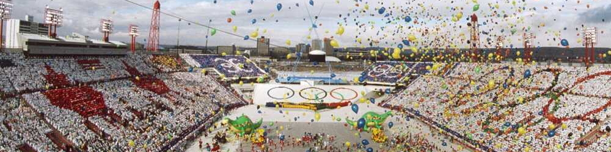

**SAé 2.04**

**Olympic Games**

**The most amazing people**

**Group work done by :**

* Antoine POURTHIE
* Antoine DOMISSE

**Group : B**

**The youngest athlete**

Dimitrios Loundras was born on September 6, 1885 in Athens and died on February 15, 1970 at the age of 84 years old. As a gymnast, he was part of a team called Ethnikos Gymnastikos Syllogos". At the age of 11, during the Summer Olympics of 1896 in Athens, he won a bronze medal in the event of parallel bars in artistic gymnastics. He is the youngest medalist and competitor in Olympic history. Later, Loundras became an officer of the "Royal Hellenic Navy", which is the naval force of Greece; he also participated in the first world war.

**The oldest athlete**

John Quincy Adams Ward was an American sculptor who was born on June 29, 1830 in Urbana and died on May 1, 1910 in New York, at the age of 79.

During his childhood, he developed a passion for sculpting small animals with clay. He continued to perfect his skills in modeling and sculpting with clay, plaster, marble, and bronze. He participated in the 1928 Summer Olympics in the sculpture event of the art competition, making him the oldest person registered in the Olympics.

**The lightest of all athletes**

Choi Myong Hui is a gymnast from North Korea, born on June 13, 1966. She participated in six events at the 1980 Summer Olympics. She is currently the lightest person to have participated in the Olympic Games with a mass of 55 lb (25 kg).

**The heaviest of all athletes**

Ricardo Blas Jr was born on October 19, 1986 in Tamuning. He is a judoka from Guam, which is an island located in the southeast of the Philippine Sea. He competed in the Olympic Games in 2008 and 2012. His father, judoka Ricardo Blas also participated and is now president of the Olympic Committee of Guam.

He is the heaviest athlete in the history of the Olympics, also nicknamed "the little mountain" with a mass of 480 lb (218 kg).

**The tallest of all athletes**

Yao Ming was born on September 12, 1980 in Shanghai. He is a Chinese basketball player. During his career, with a height of 7ft 6in (2.29 m), he was the tallest player in the NBA. Before joining them, he won a championship with his former team, the CBA (Chinese Basketball Association). He retired around 2011 due to several foot injuries.

**The smallest of all athletes**

Rosario Briones was born on October 5, 1953 in San Luis Potosi, Mexico. She is a gymnast who participated in six events at the 1968 Summer Olympics. She is the smallest participant in the Olympic Games with a height of 4ft 2in (1.27 m).

**The youngest athlete in basketball**

Yi Jianlian was born on October 27, 1987 in Heshan, China. He is a Chinese basketball player who made his debut in the CBA (Chinese Basketball Association) at the young age of 16 years, however, thanks to his great size with his 6ft 12in (2.13 m), age was not a problem. He is the youngest basketball player to have participated in the Olympic Games. Later on in his career, he and his team, the Guangdong Southern Tigers, won the national championship three years in a row.